DIGITAL NOTES ORGANIZER
@CREATIVITY THINK (9483175986/7019689991)

ABSTRACT:
The Digital Notes Organizer is a web-based application designed to help users create, edit, categorize, and efficiently manage their notes in a centralized digital environment. The system supports folder-based and tag-based organization, advanced search and filtering, and dashboard analytics for tracking usage patterns. Ideal for students, researchers, and office staff, the platform ensures structured organization and quick retrieval of information. Developed using Django and Django Rest Framework on the backend and React with Redux and axios on the frontend, the system delivers a seamless note-management workflow with powerful categorization tools and real-time analytics..

INTRODUCTION OF THE PROJECT:
Managing large collections of notes manually or across different platforms often leads to disorganization, difficulty in retrieval, and lack of centralized storage. Students and professionals face challenges in maintaining subject-wise categorization, applying tags, and searching notes efficiently. Traditional tools lack unified dashboards and analytical insights. The Digital Notes Organizer addresses these challenges by offering a structured, searchable, and analytics-driven digital platform that allows users to create, edit, tag, filter, and organize notes within folders. It enhances productivity, ensures proper note management, and improves the accessibility of information..

PROJECT OBJECTIVES:

• Provide a centralized platform for creating and editing digital notes
• Enable tag-based and folder-based organization for efficient categorization
• Offer search and filtering to quickly locate specific notes
• Display analytics to help users understand note usage and structure
• Provide administrators with tools to moderate notes and manage tags/folders
• Ensure secure storage and fast retrieval of notes
• Improve productivity through structured organization
• Support large-scale note management for academic and professional use

PROBLEM OF THE STATEMENT:
Users who rely on manual note-taking or unorganized digital files struggle with scattered information, lack of categorization, and inefficient retrieval. Traditional applications often lack tagging systems, folder organization, and comprehensive dashboards. Without advanced search and filters, users spend unnecessary time locating important notes. Administrators also lack control mechanisms to moderate or categorize content. The Digital Notes Organizer solves these issues by providing a powerful note management system that integrates tags, folders, analytics, and structured workflows to ensure optimal accessibility and organization..

MOTIVATION OF THE PROJECT:
• To help users maintain well-organized and easily retrievable notes
• To provide structured tagging and folder management
• To reduce time spent searching for information
• To enhance digital productivity through analytics insights
• To assist institutions in managing large volumes of notes securely
• To create a scalable digital organization platform for general and academic use

BLOCK DAIGRAM OF PROJECT:

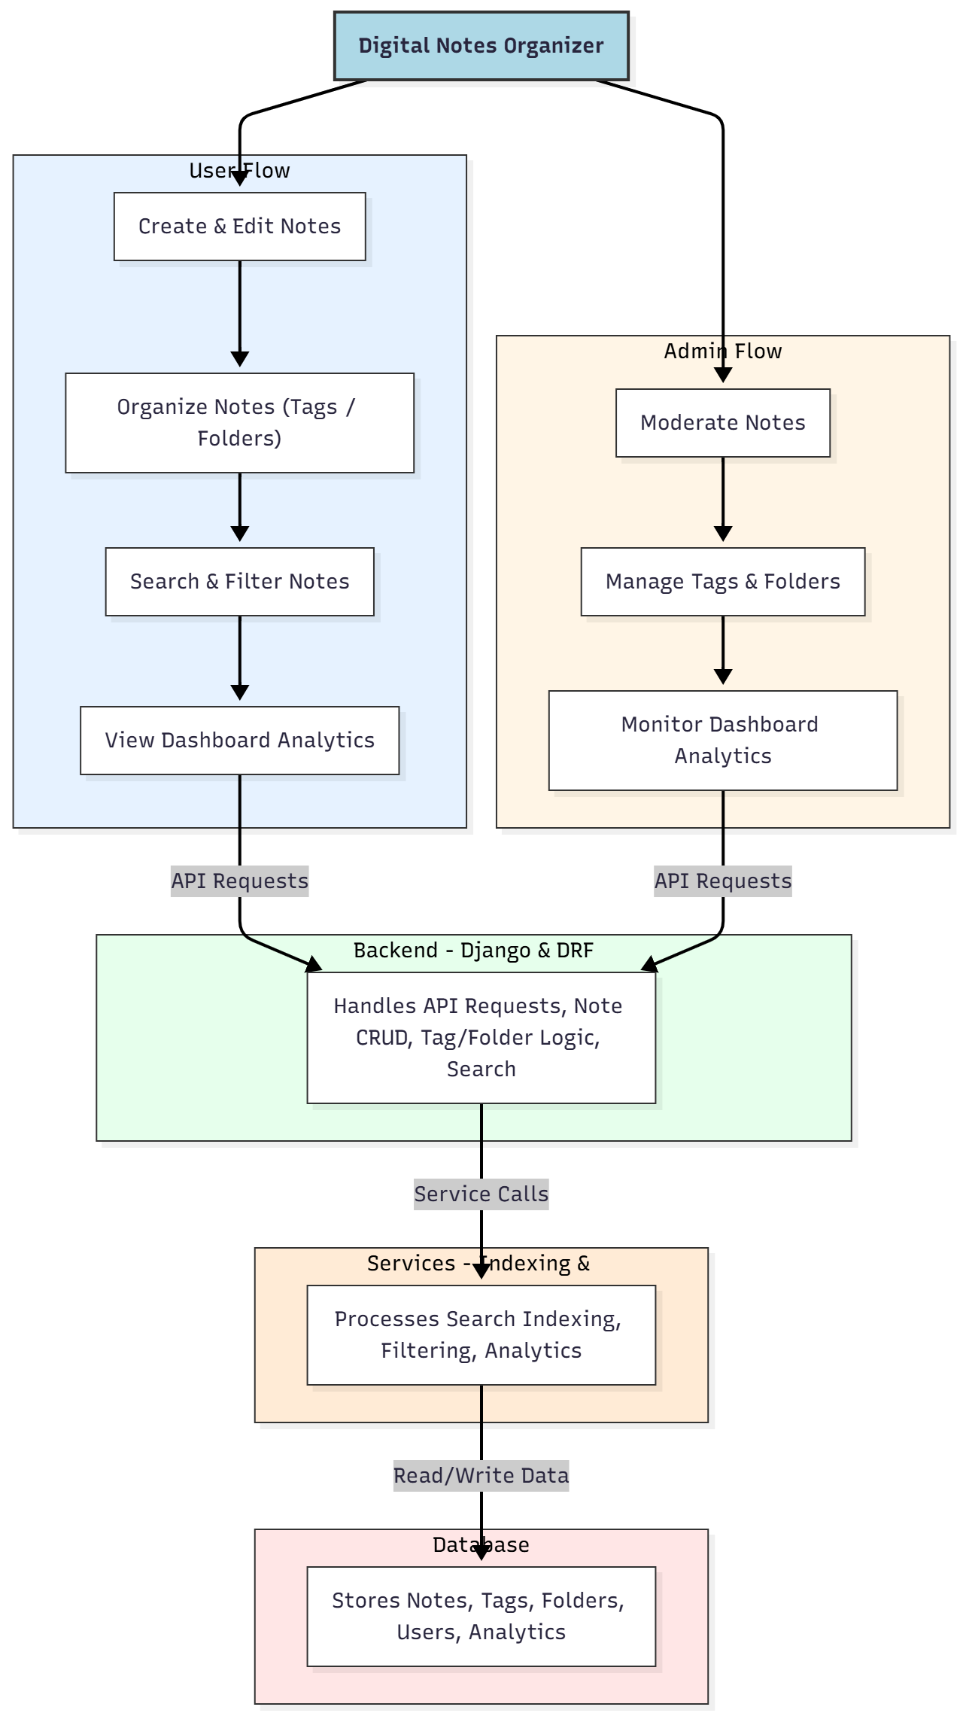

WORKING OF THE PROJECT:
The system begins when a user creates or edits a note using the text editor interface. Notes can be assigned tags and placed into folders, which the backend stores securely. Search and filter features retrieve notes based on keywords, tags, or categories using the analytics and indexing service. The dashboard displays note usage statistics, such as most-used tags or notes created over time. Administrators can moderate content, manage tags and folder structures, and access advanced analytics. This workflow ensures a smooth and organized note-management experience suitable for personal, academic, and organizational use..

SOFTWARE REQUIREMENT:
- Backend:
  - Python 3.x
  - Django
  - Django REST Framework
  - SQLite/PostgreSQL
- Frontend:
  - Node.js and npm
  - React.js
  - Axios
- Development Tools:
  - Visual Studio Code
  - Postman (for testing APIs)
  - Git/GitHub (for version control)
- Server/Deployment (Optional):
  - Gunicorn, Nginx, or Heroku/AWS for hosting

ADVANTAGES OF THE PROJECT:

• Provides structured note management with tags and folders
• Enables quick retrieval using search and filters
• Offers dashboard insights on note organization and usage
• Ensures secure and centralized storage of user notes
• Enhances productivity for students, researchers, and professionals
• Supports large-scale note-taking with efficient categorization
• Helps administrators maintain structure and moderation
• Improves accessibility and management of academic or office notes

APPLICATIONS OF THE PROJECT:
• Student note-taking and organization
• Research documentation and categorization
• Office and workplace information management
• Digital diary or knowledge management systems
• Academic content organization
• Project documentation storage
• Multi-folder note-based study systems

REFERENCES:

- Django REST Framework Documentation — Django Software Foundation. Django Documentation. Available: https://docs.djangoproject.com/
- Django REST Framework. DRF Documentation. Available: https://www.django-rest-framework.org/
- React. React Official Documentation. Available: https://reactjs.org/docs/getting-started.html
- Redux. Redux Documentation. Available: https://redux.js.org/introduction/getting-started
- PostgreSQL Global Development Group. PostgreSQL Documentation. Available: https://www.postgresql.org/docs/
- MySQL. MySQL Reference Manual. Available: https://dev.mysql.com/doc/
- Git. Git Documentation. Available: https://git-scm.com/doc
- Node.js. Node.js Documentation. Available: https://nodejs.org/en/docs/
- Axios. Axios Documentation. Available: https://axios-http.com/docs/intro
- Socket.io Documentation – https://socket.io/docs/

